

**Proposal and Quotation for WhatsApp Blue tick**

https://www.veloxn.com/

**Introduction –**

Thank You for showing interest in WhatsApp Blue tick Service for lifetime with Veloxn Private Limited.

**Service Cost -**

The table below details the cost associated with this service.

|  |  |  |  |  |
| --- | --- | --- | --- | --- |
| **Name** | **Price** | **Qty.** | Validity | **Final Subtotal** |
| WhatsApp Blue tick for lifetime | ₹16,500 | 1 | Lifetime | ₹16,500 |
|  |  |  |  |  |
|  |  |  |  |  |
| **Sub Total** |  |  |  | ₹16,500 |
| **GST (18%)** |  |  |  | ₹2,970 |
| **TOTAL Including GST** |  |  |  | **₹19,470** |

Payment required is **₹19,470**

**Note\*** - Offer Valid for 7 days only

**Bank Details**:

**VELOXN PRIVATE LIMITED**

AC Number – 259958439076

IFSC Code – INDB0000702

Bank Name – Indusind Bank

UPI ID - veloxnservices@okicici

QR Code – 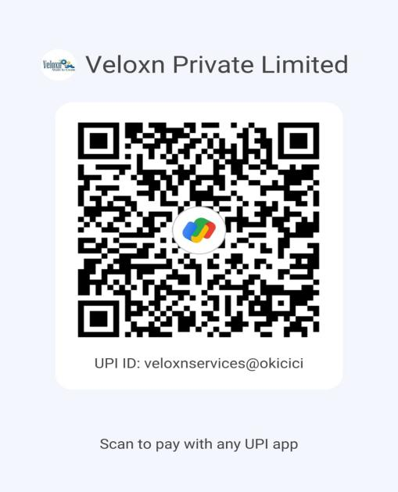

**COMPANY:**

Veloxn Private Limited

Iconic Tower C, Corenthum, Sector-62, Noida, UP - 201301, India www.veloxn.com

sales@veloxn.com

91-7292001010

GST - 06AAICV7138B1ZE